

NATIONAL AERONAUTICS AND SPACE ADMINISTRATION

FINAL

APOLLO 7
RENDEZVOUS

AS-205/CSM-101

(OCTOBER 11 LAUNCH)

PREPARED BY

FLIGHT PLANNING BRANCH
FLIGHT CREW SUPPORT DIVISION

MANNED SPACECRAFT CENTER
HOUSTON, TEXAS

This document was written for use with Project Apollo for Orbiter (NASSP) by Charles Patterson (pattersoncr at the Meadville Space Center Forums).
Page size is set up for bookfold format using letter size paper (8½ x 11in). "Courier New" font was used throughout to make this document look as much as possible like the original NASA checklists.
There are some portions of the original NASA procedures that are not yet supported by NASSP. These steps are either omitted or included in GRAY.
Text in italics indicates steps that are required specifically for Orbiter that were not part of the NASA checklists.
Keyboard presses are shown in {curly brackets}. On screen MFD button clicks are shown in [brackets]. MFD on screen parameters are listed in "quotes".

Other procedures are referenced in the following format (Letter(s)/Page Number): "GDC ALIGN pg G/7-4"

E CSM Entry Checklist
F Mission Flight Plan
G CSM G&C Checklist
L CSM Launch Checklist
LA LM Activation Checklist
LGC LM G&C Checklist
LL LM Launch & Ascent Checklist
S CSM Systems Checklist
EMER Emergency Procedures
(Contained in CSM Systems Checklist)
SUR LM Surface Checklist

1 TIMELINE 1-1
TPI 1-1
TPF 1-3
Reference 1-4
2 PRETHRUST PROGRAMS 2-1
P34 – TPI PRETHRUST 2-1
P35 – TPM PRETHRUST 2-2

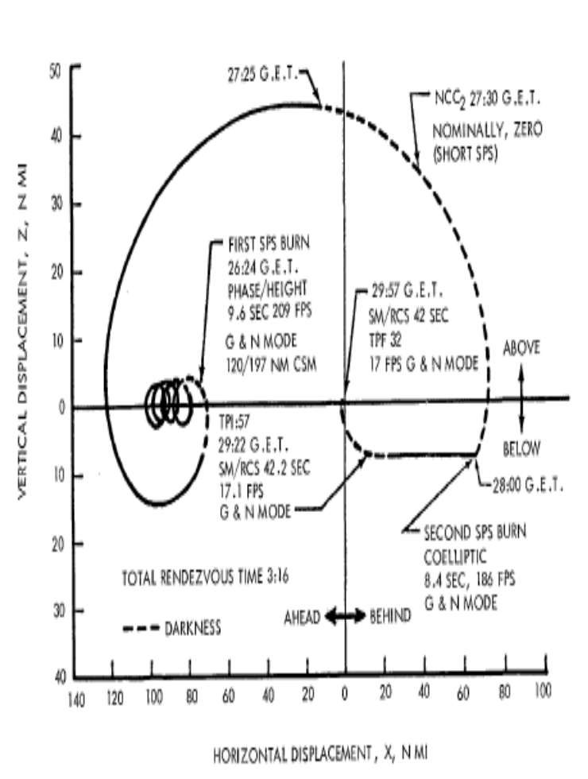

RENDEZVOUS Nomenclature
Nominal GET | Flight  Plan | RDV  Spreadsheet | Notes
026:25 | NCC1 | Insertion | 1st SPS Burn or  "Corrective Combination"
027:30 | NCC2 | CSI | Nomially 0 fps
028:00 | NSR | CDH | 2nd SPS Burn
029:16 | TPI | TPI

This document serves as a single procedure with which to conduct the rendezvous, minimizing the need to reference other documents. Detailed instrustions for rendezvous prethrust (P34/35) programs are available on page R7/1. Instructions for P20 (including V57 marking routine, etc.) are available at G/3-1.

TIMELINE

TPI
Perform the following immediately after completing the P40 C/L for the NSR/CDH Burn. Times at left refer to Event timer counting upto (and after) TPI:

Update SV for CSM and S-IVB G/3-10

V37E20E Auto-maneuver to Tracking Attitude G/3-1
Once R1,2,3 blank, Call P34
V37E34E
At F 06 37 Load Nominal TPI TIG
PRO
At F 06 55 Load the following Values:
R2: +02745 (Elevation Ang = 27.45°)
R3: +14000 (Central Angle = 140.00°)
At F 06 37 Record TPI TIG
At F 06 81 Record ∆V X,Y,Z (N81)
At F 16 45 SET EVENT TIMER counting up to TPI
Key V32E
(Do not PRO from F 16 45 until final P34 at TPI -15min.)

56:00 Make 10 Marks on S-IVB
(TPI -64m) (V57E from any flashing V/N display)
Run P34 again, Record TIG & ∆V

18:00 Update ORDEAL
(V82 for HA & HP, V83 for θ)

22:00 Make 5 – 10 Marks on S-IVB (V57)

25:00 Update SV Update for both vessels

30:00 Reset W Matrix:
Key V24N01E (WRENPOS – 1000ft)
Key 2000E (WRENVEL – 1fps)
Key 47E
Key 20E
KEY RLSE
35:00 Make 10 Marks

45:00 Run P34 Again. Record TPI Solution.
Update EMS ∆V Counter

49:00 V37E41E
Maneuver to Burn Attitude

59:00 EMS MODE – NORM

59:35 DSKY Blanks

59:30 Avgerge G on
F 16 85 Thrust Forward to zero ∆V Counter
Null residuals to <.5fps
PRO
At F 37 Key 35E

04:00 Make one "Phoney Mark"
(TPI +4m) V81E (Marks will now update CSM SV)

08:00 Complete Marks
PRO

12:30 PRO from F 16 45 (This will set the time
for Midcourse Correction for 90s later)
At F 06 81 Record ∆V X,Y,Z
V37E47E

14:00 Thrust to match recorded ∆V X,Y,Z
(Maintain tracking attitude)

15:00 V37E35E

18:00 V54E (COAS marking routine)
At F 06 94 Load COAS angles:
R1 00000
R2 57470
PRO
V77E (COAS tracking attitude)

19:30 PRO from F 16 45
At F 06 81 Record ∆V X,Y,Z
V37E47E
21:00 Thrust to match recorded ∆V X,Y,Z

Once second midcourse complete, make no further marks. Follow guidance for TPF.

TPF
Following second midcourse:
- Boresight S-IVB in COAS. Maintain Attitude with SCS:
SC CONT – SCS
MAN ATT (3) – RATE CMD
BMAG MODE (3) – ATT1/RATE2
- Determine Drift Rate by measuring time required to drift .5°, 1°, 1.5°, or 2° in COAS reticle. (Reticle is marked with + at 1° intervals horizontally and vertically.)
- Make corrections in accordence with the following graphs to reduce lateral drift rate.
- Select P47 Prior to applying translation thrust.
- Recenter S-IVB in COAS as necessary.
- Frequently monitor Range and Range Rate (R DOT) using V83 or V85
- Keep S-IVB centered in COAS and thrust aft to reduce range rate in accordence with the following Range Gates:
R 1.0 nm R DOT to 25 fps
R 0.5 nm R DOT to 15 fps
R 0.25 nm R DOT to 10 fps
R 0.15 nm R DOT to 5 fps
The Docking MFD may be used to duplicate V83
Range/Range Rate tracking. Use the following
Range Gates:
R 1852 m R DOT to 7.6 m/s
R 926 m R DOT to 4.6 m/s
R 463 m R DOT to 3.0 m/s
R 278 m R DOT to 1.5 m/s

Reference
S-IVB Drift Rate
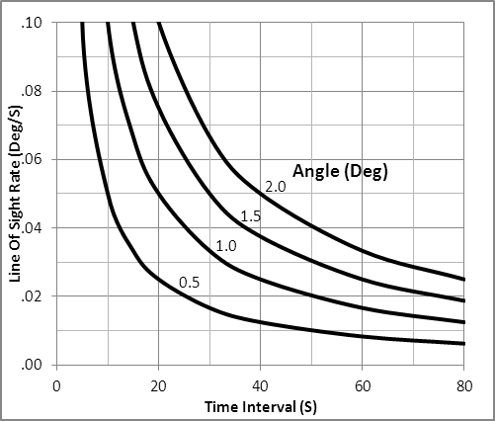

Lateral Thrust Required for Corrections
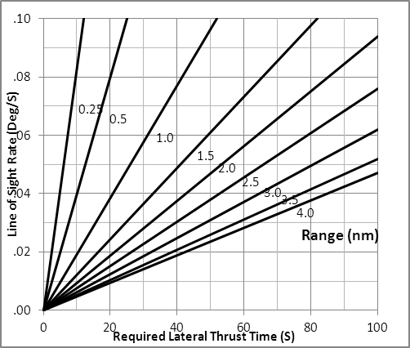

Thrust in direction of drift

Selected Verbs:
32 Recycle Prog
51 Please Mark
53 Please Mark alternate LOS
54 Start RNDZ backup sighting mark (R23)
∗ 56 Terminate Tracking
57 Start RNDZ sighting mark (R21)
76 Set Preferred ATT Flag (SXT)
77 Reset Preferred ATT Flag (COAS)
∗ 80 Update LM State Vector
∗ 81 Update CSM State Vector
82 Start Orbit Param Disp (R30)
83 Start RNDZ Param Display No.1 (R31)
85 Start RNDZ Param Display No.2 (R34)
∗ 86 Reject RNDZ backup sighting mark
89 Start RNDZ Final ATT Maneuver (R63)
Selected Nouns:
37 GETI (TPI) hrs,min,.01sec
45 Marks (VHF-optics) XXBXX
TFI (next burn) min-sec
MGA .01°
49 ∆R (State Vector Position Update) .01nm
∆V (State Vector Velocity Update) .1fps
Source code (1 optics,2 VHF)
53 Range .01nm
Range Rate .1fps
PHI (lcl horiz/SLOS) .01°
54 Range .01nm
Range rate .1fps
Theta (lcl horiz/+X Axis) .01°
55 Precision offset CODE
E (ELEV ANGLE) .01°
Central Angle (passive veh) .01°
58 HP alt (post TPI) (RLS/Pad) .1nm
∆V (TPI) .1fps
∆V (TPF) .1fps
59 ΔV LOS 1 .1fps
∆V LOS 2 .1fps
∆V LOS 3 .1fps
81 ∆VX,Y,Z (lcl vert) .1fps
83 ∆VX,Y,Z (Body Control Axis) .1fps
85 VGX,Y,Z (Body Control Axis) .1fps
94 Alternate LOS - R1 SHAFT .01°
- R2 TRUNNION .001°

PRETHRUST PROGRAMS

P34 – TPI PRETHRUST

PURPOSE: P34 TPI is performed by active vehicle. P74 TPI Targeting is performed by passive vehicle. To compute parameters required for execution of the Transfer Phase Initiation (TPI) maneuver given TIG or E (ELEV ANGLE) and CENTANG

ASSUMPTION: P17 used to calculate givens above (pg LGC/x-x). P33 must have been successfully completed. May be performed concurrently with P20. Minimum HP, RR, & IMU as per P32.

1 V37E 34E (74E)
F 06 37 TIG TPI (hrs,min,.01 sec)
PRO

2 F 06 55 N,ELEV ANGLE,CENTANG (passive veh)
(0000X,.01°,.01°)
Load Desired CENTANG in R3
(00000 in R2 to compute
ELEV ANG at TIG time)
PRO

3 F 16 45 MARKS,TFI,MGA(-00001) (marks,min-sec)
(RECYCLE) V32E
(TERM MARKING) PRO
*F05 09 00611 No TIG for *
* specified angle*
* PRO To 1 *

4 F 06 37 TIG TPI (hrs,min,.01 sec)
PRO
(If ELEV ANG computed by AGC
this display will be replaced by
F 06 55
PRO to 5)

5 F 06 58 HP,∆V(TPI),∆V(TPF), (.1nm,.1fps,.1fps)
PRO (If Recycling to 7)

6 F 06 81 ∆V XYZ (LV) TPI (+fwd,+rt,+dn) (.1fps)
PRO

7 F 06 59 ∆V XYZ (LOS)TPI (.1fps)
PRO

8 F 16 45 MARKS,TFI,MGA(-00002 IF no REFSMMAT set)
(marks,min-sec,.01°)
SET EVENT TIMER to TFI
PRO
12 F 37

P35 – TPM PRETHRUST

PURPOSE: P35 TPM is performed by active vehicle. P75 TPM Targeting is performed by passive vehicle.To compute required ∆V and other parameters required for execution of the next miscourse correction of the rendezvous transfer phase.

ASSUMPTION: TIG is calculated by P34. May be performed concurrently with P20.

1 V37E 35E (75E)
F 16 45 MARKS,TFI,MGA(-00001) (marks,min-sec,.01°)
(RECYCLE) V32E to 3
(FINAL PASS) TERM MARKS, PRO to 4
*F 0509 (00611 NO SOLN)*
*PRO to 1 *

2 F 06 81 ∆V XYZ (LV) TPM (.1fps)
PRO
3 F 06 59 ∆V XYZ (LOS) TPM (.1fps)
PRO (if Recycling to 1)

4 F 16 45 MARKS,TFI,MGA(-00002 IF no REFSMMAT set)
(marks,min-sec,.01°)
SET EVENT TIMER to TFI
PRO
7 F 37

